**ECE 416 Senior Design Project Report**

**Team number # 9**

Project Title:      **Radio-Frequency Identification Operating Pet Doors**

Name(s):            Raddath Juhuri (EE)          ID#              31429667

Name(s):                 Nada Sharaf (EE)              ID#              31411637

Name(s):                 David Ifesanya (EE)         ID#               31341923

Advisors and Mentor:

* Marek Sosnowski
* Leonid Tsybeskov

Submission Date: 11/11/18

Radio-Frequency Identification Operating Pet Doors for Security Purposes

Team Members:

* Raddath Juhuri
* Nada Sharaf
* David Ifesanya

Advisors and Mentors:

* Marek Sosnowski
* Leonid Tsybeskov

**Abstract:**

The proposed project is about designing and implementing a RFID pet door for small pets. The device is intended to provide safety and comfort for pet owners using Radio Frequency (RF) waves, which allows the pet door to open and close automatically when the intended animal(s) is within a specific range. The major components used in the design of the project are RF reader, a RF tag, an Arduino UNO, three IR proximity sensors and two solenoids. The design and implementation will include an Arduino programming and will find the range of the RFID for the best possible accuracy. In the project, we have been able to include three IR proximity sensors on one side of the door and the RFID reader module on the other side of the door. The IR sensor would be attached on the door in the house (exiting the house) to detect the animal, the RFID would be used outside the house (entering the house) to allow for a specific animal with RF tag to get in. We also worked on trying to make it more user interactive by allowing the user to receive a push notification every time the door is opened in either direction.

**Table of contents**

1

2

2

2

3

3

5

5

5

6

6

7

8

8

9

Introduction ------------------------------------------------------------------------------------------------

* Project Objective --------------------------------------------------------------------------------
* Project Significance -----------------------------------------------------------------------------
* Project Novelty ----------------------------------------------------------------------------------

Project Accomplishments -------------------------------------------------------------------------------

* 2.1. Technical Details ---------------------------------------------------------------------------
* Specifications ---------------------------------------------------------------------------
* Engineering Standards ---------------------------------------------------------------
* 2.2. Testing and Performance Measures --------------------------------------------------
* 2.3. Future Potential ---------------------------------------------------------------------------
* 2.4. Learning Experience ----------------------------------------------------------------------

Budget--------------------------------------------------------------------------------------------------------

Acknowledgements---------------------------------------------------------------------------------------

References --------------------------------------------------------------------------------------------------

Project Appendix ------------------------------------------------------------------------------------------

1. **Introduction**

In today’s world, there are a lot of criminal activities going on around us and this subconsciously affects the way people think today. Most people are worried about their safe anywhere they go and can’t even feel safe at home. People with pets are frightened of getting a pet door for their animals because anything could come in through and into their homes. Our project is designed to make animal lovers feel more comfortable and safer about owning a pet and allowing it to interact in and outside their homes. The main idea behind our RFID operating pet door is to use an Arduino operating system to control the opening of a pet door. The full meaning of RFID is “Radio-Frequency Identification” which converts digital data in RFID tags and are received by the reader via radio waves. RFID automatically identify objects, collect data, and enter those data directly into computer systems with little or no human intervention and in this case the system would be the Arduino. The pet would wear an RFID tag which would be read by a RF reader module and then processed by Arduino after the code has been written. The RFID tag consists of an integrated circuit and an antenna. There are two types of RFID tags, passive and active. For our project we will use a passive RFID because they are smaller and less expensive to use. Also, the passive RFID is powered up whenever it comes near the RFID reader which is how we want the pet door to work. There is a similar operating door found online but ours is different because we can include a user interface that allows pet owners get a notification on their phone whenever the door in opened. There are a lot more people in the world with pets, so this product would be a success all around the world. Safety is one of the biggest issues is the world and we believe this project can help put majority of pet owners are ease.

Project Objective:

The major technical goal of our project is to provide comfort and safety for the pet and the home. This project allows the pet to come in and out of the house whenever it pleases without the owner having to worry about the risk of any other animals (e.g. raccoons, squirrels) coming into the house through the door. The door opens only for the pet whenever it is within a certain range away from the door. It also prevents other animals from entering the house and causing harm to the pets or the owner through diseases that can be the transmitted.

Project Significance:

This project is important because it helps pets feel less uncomfortable when they are home alone when the owner is at work or not around. Exercise is very useful and important for the growth and development of a pet, but most pets don’t get enough exercise because they are indoors all day. Our pet door allows the pets access to go outdoors where they can run and move around a lot more to keep themselves active and healthy. Finally, been outdoor helps improve the five of the pets which are sight, sound, taste, smell and touch. With heightened senses the pets are mental stimulated, and it helps keep them more alert and feel younger.

Project Novelty:

Compared to other already existing pet doors that are available in the market, this one is technologically advanced. This pet door will operate only when a specific pet of the owners choosing is detected by the sensor at the door which makes it is safer and more convenient. Our project must be more expensive compared to the regular pet door, but more people would prefer to buy our project because we emphasize on the fact that safety is a guarantee and with so negligible risk. Another product available in the market is an automated pet door but the problem with this product is that it only works on a timer which means the door would only open for the pet at a certain time. I don't believe this product is better than other because ours allows free reign for the animal and at the same time provides safety and security. Our product also gives users the opportunity to keep track of their pets whenever the door is opened by sending the user a push notification.

1. **Project Accomplishments**

2.1 Technical details:

The project primarily uses RFID to make an automated pet door which is designed for the safety for both the owner and the pet. The door opens only when the specific pet comes within a certain range for the antenna to pick up its signal. In order to detect the specific pet, we are using a RFID tag which will be on the collar of the pet and programmed to the RFID reader. We will also be using three proximity sensors, two solenoid locks and a reed sensor which are all connected to an Arduino UNO board. All the components work simultaneously in order to make sure the specific pet is entering and exiting the house independently. A block diagram and schematics is provided in order to show the connections of the components:

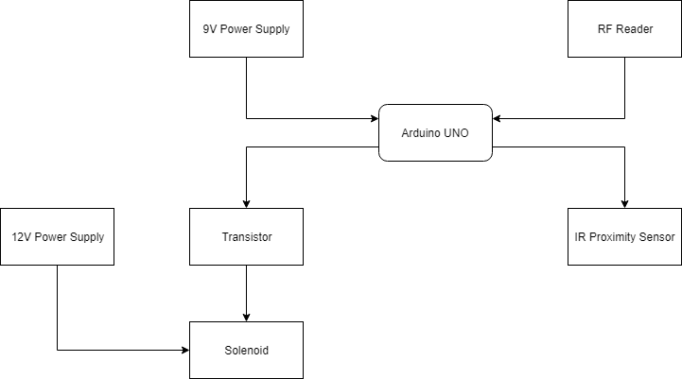

**Figure 1: Block Diagram**

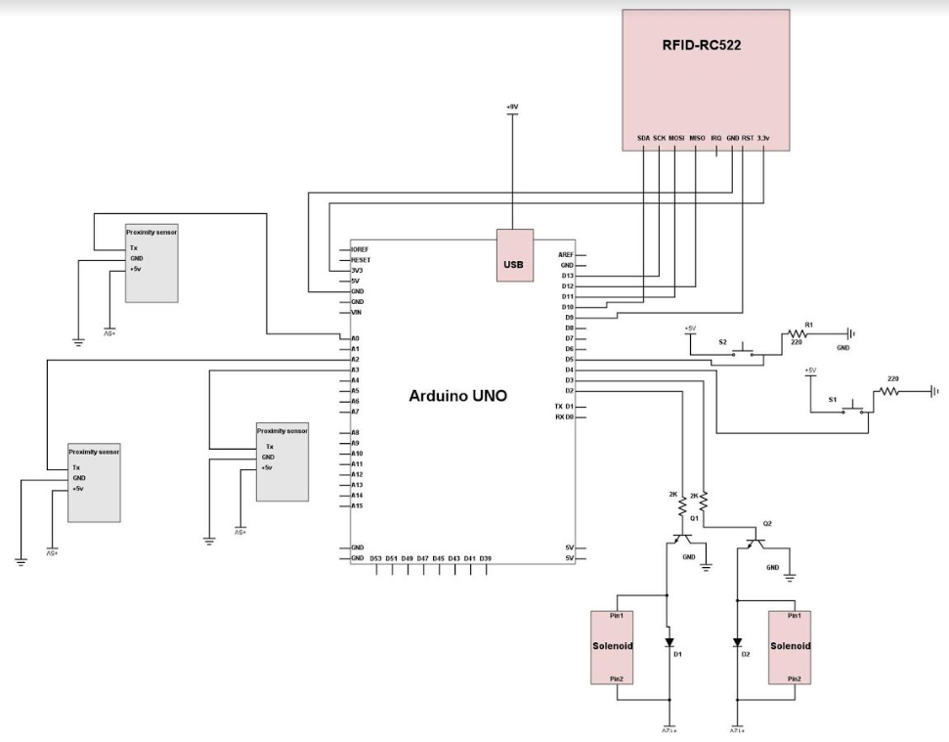

**Figure 2: Schematics Diagram with Arduino**

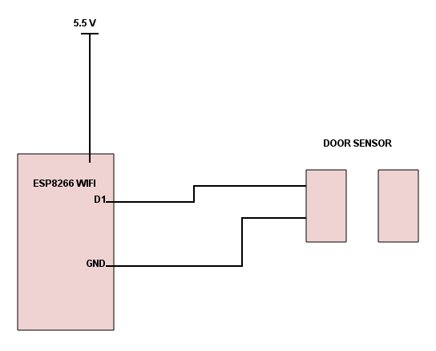

**Figure 3: Schematics Diagram of The ESP8266 Wi-Fi Module and Door Sensor**

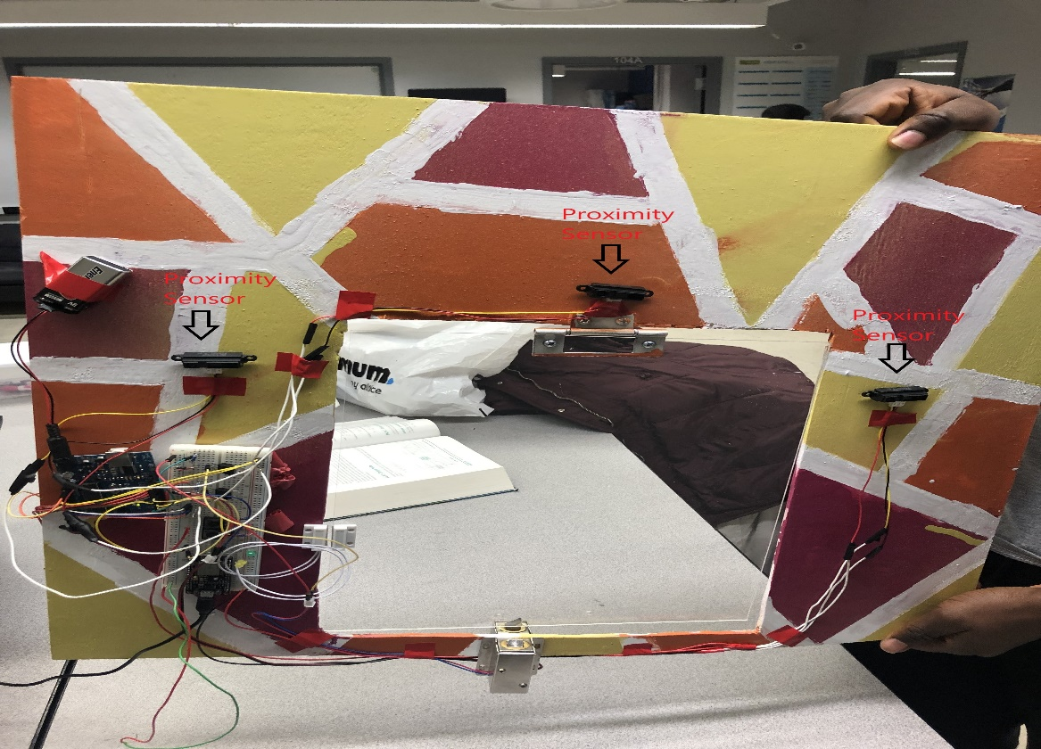

**Figure 4: Inner Part of The Door With Three Proximity Sensors**

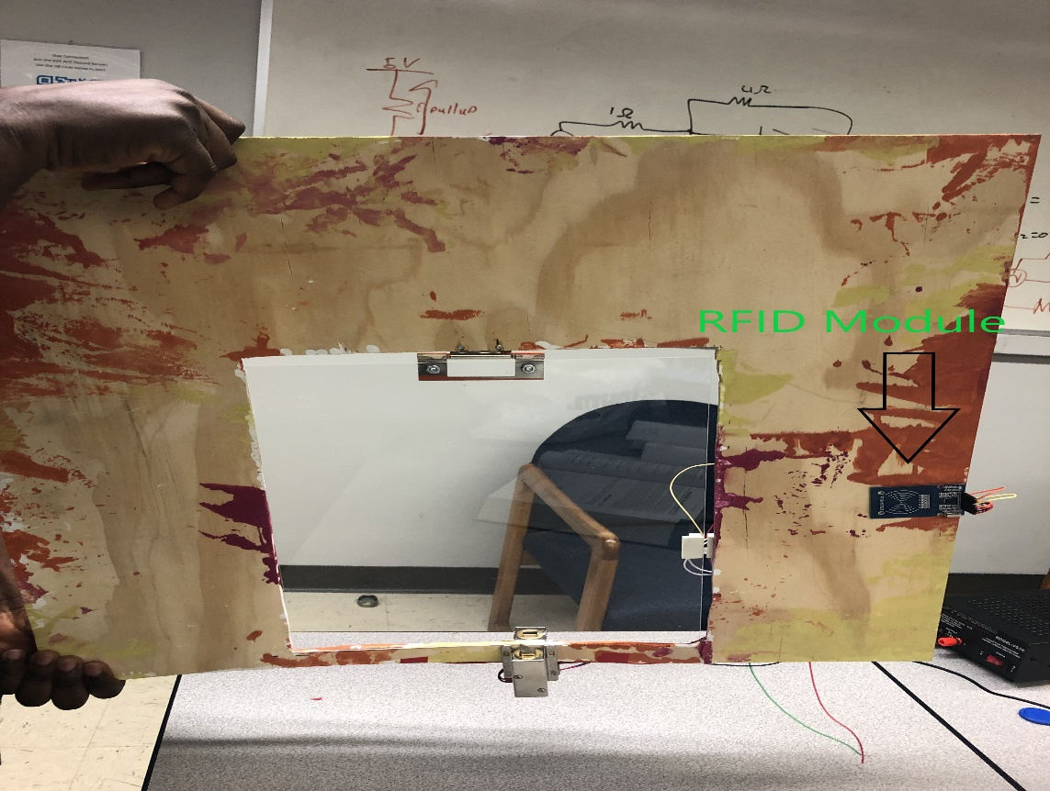

**Figure 5: Outer Part of The Door With RF Reader**

* Specifications:

The range of our RFID antenna is approximately 10 mm, we had plans to increase the range by using an external antenna in order to make the product more efficient, but we were unsuccessful in increasing the range. The range of our proximity sensor on the other hand would be up to 2 inches and can vary depending on what the threshold of the proximity sensor is set to. The product is undoubtedly cost efficient as we are using as minimal components as possible and trying to keep the cost lower. The solenoids are instantly activated when the pet is within the vicinity of the proximity sensor or the RF module. The amount of power consumption is very low making our product very energy efficient. We will only be using an additional 12V power supply while the other power supplies are acquired from the Arduino board. Our project is also very environment friendly because in the process of designing and after installment, we wouldn’t be endangering anything around.

* Engineering Standards:

RF engineering standards:

1. Exposure be limited to field levels no higher than 10 mW/cm².

2. Prevent exposures more than recognized limits to electromagnetic fields from RF sources that operate in the frequency range of 3 kHz to 300 GHz are described in IEEE Std C95.7(TM)-2014.

3. Mandates look of RF Sign.

2.2 Testing and Performance Measures:

We did all the necessary testing to check the proximity sensors, the RFID response and the push notifications from the door sensor and measured the overall performance of the product and we concluded that the product has certainly reached the goal. We set the threshold of the proximity sensor to six hundred meaning that as the pet goes closer to the door, the range of the proximity sensor increases, a solenoid is activated once the animal gets within the six hundred range as shown in the figure below. We also tested the RFID response by trying different RF tags and as expected only one specific tag could activate the other solenoid. Lastly, notifications are sent to my phone every time the door is opened as can be seen in figure 7. We also made a few adjustments along the way as we discussed our project with our advisors. We were initially going to use one IR sensor, but we later decided on three proximity sensors in order to make the range of detection higher and allow the solenoid to be more efficient. Due to the fact that the proximity sensors only detect motion in a straight line, the addition of two other IR sensors at different positions on the door allows to detect the pet from different angles.

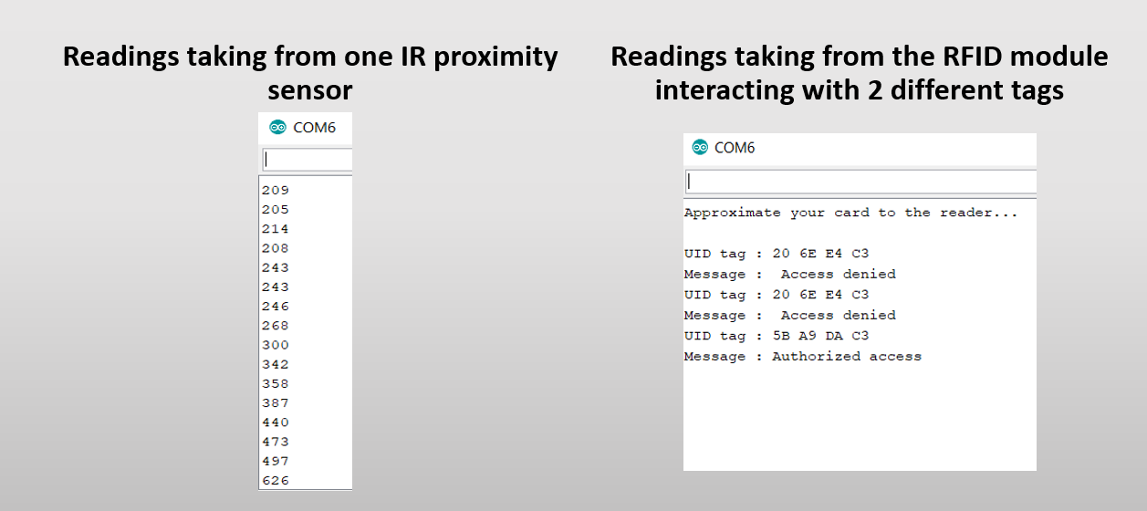

**Figure 6: Testing The Components**

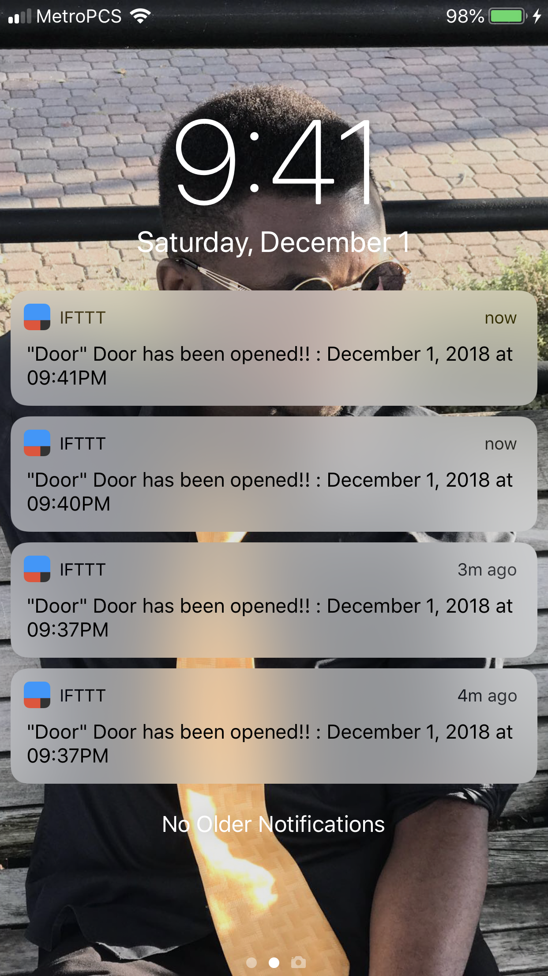

**Figure 7: Push Notifications Received When Door is Opened**

2.3 Future Potential

Our product design is more technologically developed than other similar products that are available in the market. Our product would be a great addition to commercial product because all pet lovers and owners would want to buy a product that would keep their pets safe. Pet owners would prefer our product mainly because users can keep track of their pet’s movement which other product cannot. Our product would be highly demanded for because of its advances which means it is going to be economically successful.

2.4 Learning Experience

While working on the project we learned a lot about various aspects when it comes to coding and physical designing. The components we used for the project were very new to us since we haven’t had the chance to use most of them. During the process of working on the project we came to know about different kinds of sensors, details about RFID and how to program them using Arduino. The Arduino coding for each component and merging the codes together at the end was quite a new experience and a good learning tool for us. We were also able to build our frame for the door and to do that we used saw, drills, wood sander etc. and did a lot of hands-on works that was also quite a new experience for us.

1. **Budget**

**Table 1: List of major parts and components with prices**

|  |  |  |
| --- | --- | --- |
| **Component** | **Qty** | **Price** |
| 12V Solenoid Lock | 2 | $24.10 |
| GP2Y0A21YK0F Sharp IR Analog Distance Sensor | 3 | $38.97 |
| Arduino UNO | 1 | $28.00 |
| Thick Clear Cast Acrylic Paper-Masked Sheet (11” x 14”) | 1 | $52.00 |
| IZOKEE RFID Kit, MFRC RC522 | 1 | $6.99 |
| Resistors (200kohm, 220kohm) | 6 | $1.00 |
| 1N4004 Diode | 2 | $0.50 |
| TIP120 Power Darlington Transistors | 2 | $7.49 |
| HiLetgo New Version ESP8266 NodeMCU | 1 | $8.39 |
| Gikfun MC-38 Wired Door Sensor | 1 | $5.66 |
| 12V Power Supply | 1 | $33.31 |
| 9V Energizer Battery | 1 | $12.99 |
| Board (2’ x 2’) | 1 | $5 |
| Total Cost |  | $224.40 |

1. **Acknowledgement**

We would like to express our sincere gratitude to our supervisors; Professor Leonid Tsybeskov, for helping to perfect the idea during the ECE 414 class, and Professor Marek Sosnowski, for the constant encouragement to find even better ways to improve on our project during the ECE 416 class.

We would also like to thank our friends; Smit Shah and Christopher Migdalski for being there for us whenever we needed advice. Special thanks to Wesley Scott for his assistance in the physical design of the project and Bryam Loaiza for helping with the coding. This is also dedicated to our families who supported us during the entire process. Thank you all.

1. **References**

* Instructables. “Controlling Solenoids With Arduino.” *Instructables.com*, Instructables, 5 Nov. 2017, [www.instructables.com/id/Controlling-solenoids-with-arduino/](http://www.instructables.com/id/Controlling-solenoids-with-arduino/).
* Instructables. “RFID Cat Door.” *Instructables.com*, Instructables, 3 Nov. 2017, [www.instructables.com/id/RFID-cat-door/](http://www.instructables.com/id/RFID-cat-door/).
* “Mifare MFRC522 RFID Reader/Writer.” *Arduino Playground - WhatAdapter*, playground.arduino.cc/Learning/MFRC522.
* OSIPOV, Dmitry. “Arduino NFC ANTENNA 10 Руб. MFRC522 Антенна RFID МТС Лайфхак Своими Руками.” *YouTube*, YouTube, 20 May 2016, [www.youtube.com/watch?v=JlV9_ZEfZ_g](http://www.youtube.com/watch?v=JlV9_ZEfZ_g).
* “Using IFTTT with Adafruit IO to Make an IoT Door Detector.” *Memory Architectures | Memories of an Arduino | Adafruit Learning System*, learn.adafruit.com/using-ifttt-with-adafruit-io/overview.

1. **Appendices**

**APPENDICES A**

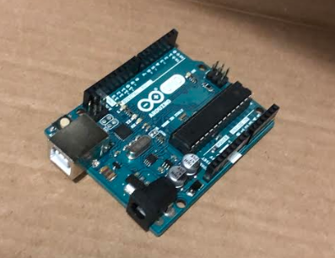

**Figure 8: Picture of Arduino UNO**

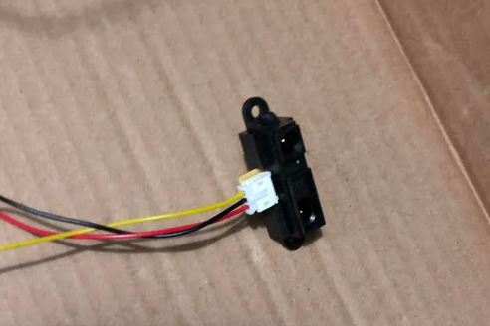

**Figure 9: Picture of IR Sensor**

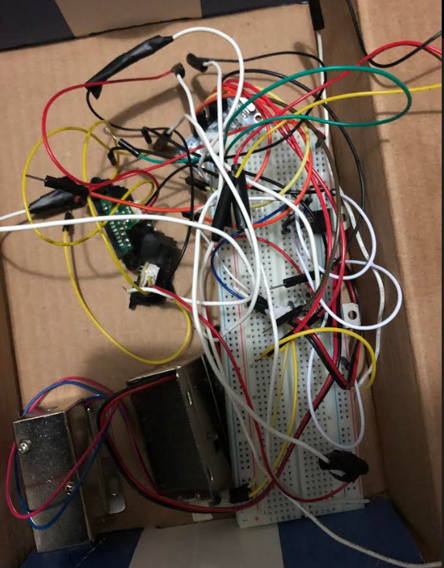

**Figure 10: Picture of IR Sensors connected with the Solenoids**

**APPENDICES B**

**Complete Code Uploaded to Arduino UNO**

#include <SPI.h>

#include <MFRC522.h>

#define SS_PIN 10

#define RST_PIN 9

MFRC522 mfrc522(SS_PIN, RST_PIN); // Create MFRC522 instance.

const int sensorPin1 = 0; //analog pin 0

const int sensorPin2 = 1; //analog pin 0

const int sensorPin3 = 2;

const int threshold = 550;

const int SOLENOID1_pin = 2; //digital

const int SOLENOID2_pin = 3; //digital

const int buttonPin1 = 4; //digital

const int buttonPin2 = 5; //digital

const int ledPin1 = 6;

const int ledPin2 = 7;

int SOLENOID1_STATE;

int SOLENOID2_STATE;

int buttonState = 0;

void setup() {

Serial.begin(9600);

pinMode(buttonPin1, INPUT_PULLUP);

pinMode(buttonPin2, INPUT_PULLUP);

pinMode(ledPin1, OUTPUT);

pinMode(ledPin2, OUTPUT);

pinMode(SOLENOID1_pin, OUTPUT);

pinMode(SOLENOID2_pin, OUTPUT);

digitalWrite(SOLENOID1_pin, LOW);

digitalWrite(SOLENOID2_pin, LOW);

SPI.begin(); // Initiate SPI bus

mfrc522.PCD_Init(); // Initiate MFRC522

Serial.println("Approximate your card to the reader...");

Serial.println();

}

void loop() {

// put your main code here, to run repeatedly:

int val1 = analogRead(sensorPin1);

int val2 = analogRead(sensorPin2);

int val3 = analogRead(sensorPin3);

if (val1 > threshold || val2 > threshold || val3 > threshold) {

digitalWrite(SOLENOID1_pin, HIGH);

delay(2000);

} else {

digitalWrite(SOLENOID1_pin, LOW);

}

Serial.println(val1);

delay(1);

buttonState = digitalRead(buttonPin1);

if (buttonState == HIGH)//debouncing

{

Serial.println("solenoid 1 ...");

digitalWrite(SOLENOID1_pin, HIGH);

//delay(1000);

digitalWrite(ledPin1, LOW);

digitalWrite(ledPin1, HIGH);

delay(2000);

digitalWrite(ledPin1, LOW);

} else {

digitalWrite(SOLENOID1_pin, LOW);

}

//button2 press opens solenoid 2 for a certain time

buttonState = digitalRead(buttonPin2);

if (buttonState == HIGH)//debouncing

{

Serial.println("solenoid 2 ...");

digitalWrite(SOLENOID2_pin, HIGH);

//delay(1000);

digitalWrite(ledPin2, LOW);

digitalWrite(ledPin2, HIGH);

delay(2000);

digitalWrite(ledPin2, LOW);

} else {

digitalWrite(SOLENOID2_pin, LOW);

}

// Look for new cards

if ( ! mfrc522.PICC_IsNewCardPresent())

{

return;

}

// Select one of the cards

if ( ! mfrc522.PICC_ReadCardSerial())

{

return;

}

//Show UID on serial monitor

Serial.print("UID tag :");

String content = "";

byte letter;

for (byte i = 0; i < mfrc522.uid.size; i++)

{

Serial.print(mfrc522.uid.uidByte[i] < 0x10 ? " 0" : " ");

Serial.print(mfrc522.uid.uidByte[i], HEX);

content.concat(String(mfrc522.uid.uidByte[i] < 0x10 ? " 0" : " "));

content.concat(String(mfrc522.uid.uidByte[i], HEX));

}

Serial.println();

Serial.print("Message : ");

content.toUpperCase();

if (content.substring(1) == "5B A9 DA C3") //change here the UID of the card/cards that you want to give access

{

Serial.println("Authorized access");

Serial.println();

//delay(3000);

digitalWrite(SOLENOID2_pin, HIGH);

delay(2000);

digitalWrite(SOLENOID2_pin, LOW);

}

else {

Serial.println(" Access denied");

delay(1000);

}

}

**APPENDICES C**

**Complete Code Uploaded to ESP8266 Wi-Fi Module**

#include <ESP8266HTTPClient.h>

#include <ESP8266WiFi.h>

#define REED_SWITCH 5 //D1

int status = WL_IDLE_STATUS; //not required.

const char* ssid = "I3E";

const char* password = "ieee_for_life";

int doorClosed = 1;

void setup() {

pinMode(REED_SWITCH, INPUT_PULLUP);

Serial.begin(115200);

setupWifi();

//get_http();

}

void setupWifi()

{

// Connect to WPA/WPA2 network. Change this line if using open or WEP network:

WiFi.mode(WIFI_STA);

status = WiFi.begin(ssid, password);

Serial.print("Attempting to connect to SSID: ");

Serial.println(ssid);

// Wait for connection

while (WiFi.status() != WL_CONNECTED) {

delay(1000);

Serial.print(".");

}

Serial.println("Connected to wifi");

}

void loop() {

if (WiFi.status() != WL_CONNECTED)

{

setupWifi();

}

// put your main code here, to run repeatedly:

if ((digitalRead(REED_SWITCH) == HIGH) && (doorClosed == 1))

{

Serial.println("DOOR OPEN!!");

while (get_http(String("DOOR_OPEN_")) != 0);

doorClosed = 0;

}

else if ((digitalRead(REED_SWITCH) == LOW) && (doorClosed == 0))

{

Serial.println("DOOR CLOSED!!");

while (get_http(String("DOOR_CLOSED_")) != 0);

doorClosed = 1;

}

delay(10);

}

int get_http(String state)

{

HTTPClient http;

int ret = 0;

Serial.print("[HTTP] begin...\n");

// configure ifttt server and url should be HTTP only..not https!!! (http://)

http.begin("http://maker.ifttt.com/trigger/Door/with/key/bW2hWpmnktoF2tr9J_IgPn8m4tszs8qVBBVp5BiN1lF"); //HTTP

//If you have enabled value1 from iftt settings then uncomment below line to send value and comment out above line

//http.begin("http://maker.ifttt.com/trigger/door/with/key/your_key_from_Iftt/?value1="+state); //HTTP

Serial.print("[HTTP] GET...\n");

// start connection and send HTTP header

int httpCode = http.GET();

// httpCode will be negative on error

if(httpCode > 0) {

// HTTP header has been send and Server response header has been handled

Serial.printf("[HTTP] GET code: %d\n", httpCode);

if(httpCode == HTTP_CODE_OK) {

String payload = http.getString();

Serial.println(payload);

}

} else {

ret = -1;

Serial.printf("[HTTP] GET failed, error: %s\n", http.errorToString(httpCode).c_str());

delay(500); // wait for half sec before retry again

}

http.end();

return ret;

}